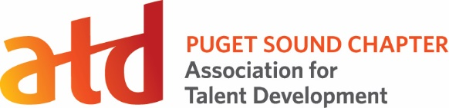
Coordinator Role

Position Title: Social Media Coordinator
Term: 15 months

Reports To: Director of Marketing & Communications

Voting Position: No

Supervisory Duties: No

Executive Committee: No

Board Appointed: No

Description:
The Social Media Coordinator increases member engagement through social media platforms such as LinkedIn and Facebook.

Time Commitment:
6-8 hours on average per month, with an expected increase in hours during key events such as the annual conference

Key Competencies:
Technological Savvy, Strategic Member Engagement

Primary Responsibilities:
- Promotes all events through the chapter’s social media platforms, including: monthly Member Events, professional development events, partnership events, ATD National learning events, etc.
- Engages with followers on social media platforms
- Increases followership and member activity over the previous year
- Recruits and trains Board members and other Board committee members to post and engage regularly on social media platforms
- Increases the visibility and reputation of the chapter through regular (3-5/week) and engaging posts

Success Measures:
- Each monthly chapter meeting is promoted at least 7 days in advance of event
- Special events (conferences, professional development events, etc.) are promoted 1-2 times per week for 6 weeks prior to event
- Followership of all social media platforms has increased over previous year
- Communicates monthly with Director of Marketing & Communications to learn of coming events
- Works collaboratively and respectfully with Board members and other volunteers

Privileges: | Additional Expectations:
Position listed on your resume and LinkedIn profile | Member of ATD Puget Sound Chapter for term
Opportunity to connect with ATDps members | Meet success measures above
Potential for career pathing into future Board positions

