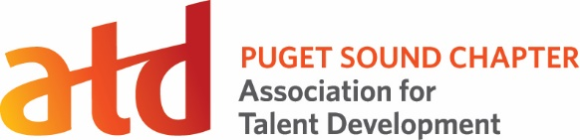
Program Manager Role

Position Title: Program Manager; Under the Hood Learning Series

Description:
Term: 15 months

Reports To: Director of Programs

Voting Position: No

Supervisory Duties: No

Executive Committee: No

Board Appointed: No

As Program Manager for the “Under the Hood” (UTH) Learning Series, you will deliver 3-4 events per year that each feature an innovative Learning and Development program and provide opportunities for attendees to network.

Time Commitment:
4 hours on average per month, with an expected increase in hours before/during/after each UTH event.

Key Competencies:
Technological Savvy, Strategic Member Engagement, Networking, Learning Event Design

Primary Responsibilities:
- Source and select UTH hosts based the Puget Sound region (with input from the Board and Director of Programs)
- Collaborate with each UTH host to create a 3-hour program
- Work with the ATDps Marketing & Communications team and Office Manager to create event pages, a marketing/communications plan, and collateral for each event
- Attend all UTH events as the ATDps point of contact, providing logistical support as needed

Success Measures:
- Deliver 3-4 UTH events per year
- UTH events receive positive feedback from attendees
- UTH events sell 75% of available seats
- Attend monthly Programs team virtual meetings
- Develop UTH host pipeline
- Works collaboratively and respectfully with UTH hosts, Board members and other volunteers

Privileges: | Additional Expectations:
Position listed on your resume and LinkedIn profile  Attend all UTH events for free during tenure | Member of ATD Puget Sound Chapter for term  Meet success measures above
Opportunity to connect with ATDps members
Potential for career pathing into future Board positions

