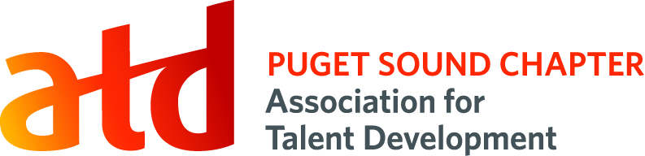
Communications Role

Position Title: Newsletter Editor
Term: 2 years

Reports To: Director of Communications

Voting Position: No

Supervisory Duties: No

Committee Members: No

Board Appointed: No

Description:
Working with both the Director of Communications and the Director of Administrative Services, the newsletter editor collects and organizes information for a short monthly newsletter to be sent out to ATDps and National ATD members.

Time Commitment:
8-15 hrs. per month depending on stakeholder delivery times and last-minute edits/additions

Key Competencies:
Written Communication and Editing, Detail-Orientation, Collaboration, Teamwork

Primary Responsibilities:
- Monthly email reminder of due date for submissions
- Ensure that copy for forthcoming newsletter has been collected on ATDps site
- Copyedit/proof all content as necessary; send queries to stakeholders
- Add/resize images as necessary
- Send newsletter (long) for review and approval before sending out
- Post finalized newsletter on ATDps site
- Send out abbreviated newsletter to ATDps members (via Wild Apricot)
- Send out abbreviated newsletter to ATD National members (via YMLP)
- Communicate with board members as required

Success Measures:
- Newsletter is sent on the 1st business day of each month
- Newsletter has copy in each of core sections (President’s message, Membership, etc.)
- Click-throughs to newsletter increase over previous year

Privileges: | Additional Expectations:
Position listed on resume and LinkedIn | Member of ATD Puget Sound chapter for term
Potential for career pathing to other Board roles | Meet success measures listed above

