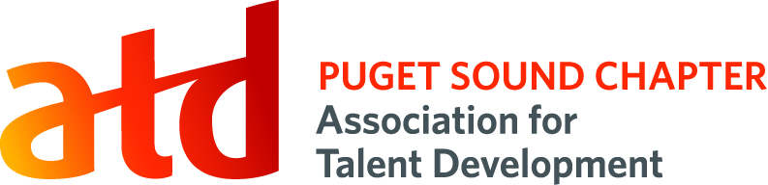
Coordinator Role

Position Title: Social Media Coordinator
Term: 15 months

Reports To: Director of Communications

Voting Position: No

Supervisory Duties: No

Executive Committee: No

Board Appointed: No

Description:
The Social Media Coordinator increases member engagement through social media platforms such as LinkedIn, Twitter and Facebook.

Time Commitment:
5-10 hours on average per month, with an expected increase in hours during key events such as the annual conference

Key Competencies:
Technological Savvy, Communication, Strategic Member Engagement

Primary Responsibilities:
- Promotes all events through the chapter’s all three social media platforms, including: monthly chapter meetings, chapter conference, professional development events, partnership events, ATD National learning events, etc.
- Improves member engagement through social media platforms
- Increases followership and member activity over the previous year
- Recruits and trains Board members and other Board committee members to post and engage regularly on social media platforms
- Increases the visibility and reputation of the chapter through regular and engaging posts
- Regularly update the Manager’s Choice section of the ATDps LinkedIn page
- Regularly post jobs on the ATDps LinkedIn page (from our yahoo group or other sources)

Success Measures:
- Each monthly chapter meeting is promoted at least 7 days in advance of event
- Special events (conferences, professional development events, etc.) are promoted 1 to 2 times per week for 8 weeks prior to event
- More than 5 voices are represented on the chapter’s social media platforms each quarter
- Followership of all three social media platforms has increased over previous year
- Communicates monthly with Director of Communications to learn of coming events
- Works collaboratively and respectfully with Board members and other volunteers

Privileges: | Additional Expectations:
Position listed on your resume and LinkedIn profile | Member of ATD Puget Sound chapter for term
Opportunity to connect with ATDps members | Meet success measures above
Potential for career pathing into future Board positions | Provide annual budget numbers

